Problem Statement
International students at KAIST struggle to discover diet-relevant, trustworthy, and up-to-date food recommendations, both on campus and in the surrounding area, which consistently leads to missed culinary opportunities, limited cultural exchange, unpleasant surprises, and difficulties in adhering to dietary restrictions.

Task Descriptions
- Leaving a review
The user is able to search up the restaurant that they have just eaten at, and leave a review. To do so, they take or upload a picture of the food, followed by adding the meal’s name, price, specific food-related tags, star rating and the actual written review.

- Finding restaurants on the map
By pressing one of the menu buttons, the user is able to see a map, with the different restaurants in the vicinity being shown there. From there, they can see the main details of the restaurant that was clicked on, and directly be directed to the page without needing to manually search it afterwards.

- Getting recommendations from past reviews
The user is able to get specific reviews catered to their preferences depending on what previous reviews they have left on the app. There they can either select whether they like or dislike the recommendation that was given, being able to access the restaurant page and meal reviews, while also getting more information allowing for better future recommendations.

Prototype
The tool portrays a mobile app with different pages for searching and leaving reviews, accessing the map, and getting recommendations. It solves the problem posed by having the reviews be purely user driven, while also making other restaurants easier to find and judge by using the recommendation system, or by using the map to find them depending on the location.

Figma link:
https://www.figma.com/design/D3jGkl8R0pal8vU7pyto0S/MealMap?node-id=37-12&t=ZJ8Z7e4pasM5TG0a-1
(The prototype is on the 2nd page. The link to the prototype can’t be shared directly with a free plan)

Design choices:
- Did not include the separate searching page for restaurants since it is redundant with other already existing apps
- Did not include additional hardcoded data for the restaurant search and text review for the review function since the main utility does not rely on these systems
- Did not include the flow for adding a new restaurant as it is less core relevant to the user’s experience than the other tasks

Screenshots:
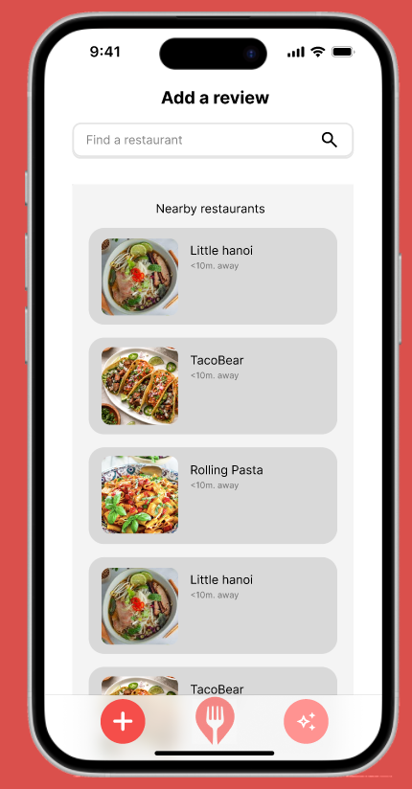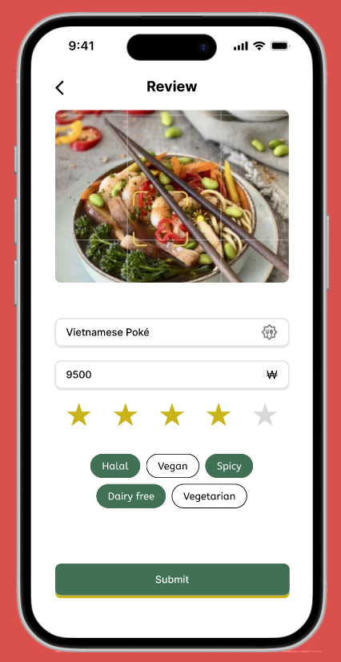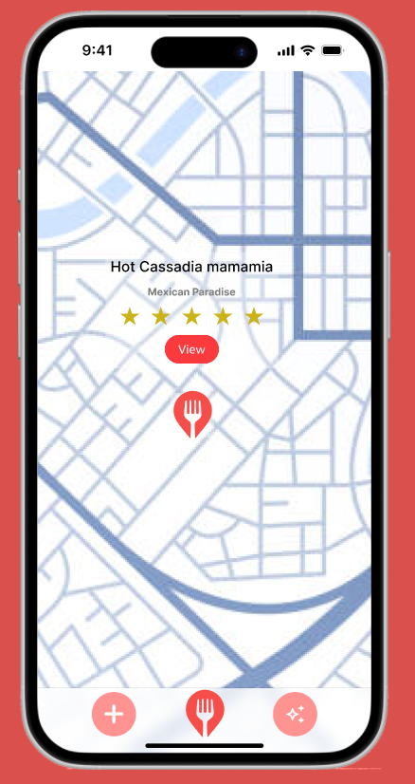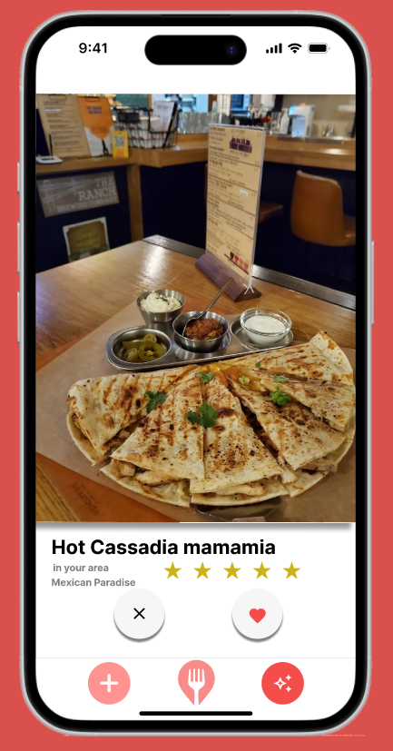

Instructions:
- Leaving a review
  - On the starting page, click any restaurant
  - Press the photo button to progress to the next page
  - The options: halal, spicy and dairy free can be selected in this specific order only
  - By pressing the 4th star, the star rating, as well as the name and price is added
  - To submit, press the submit button
  - Press the “Dismiss” button to return to the main page
- Looking on the map
  - When on the main page, press the 2nd icon on the bottom with the fork symbol on it
  - The map can scroll around and see the 3 different locations
  - By scrolling all the way to the bottom left, you can click and see the information of that specific restaurant.
  - By pressing the “View” button, the restaurant’s page appears with all the necessary details there
- Getting recommendations
  - From either the home page by pressing the bottom right menu button, or from the review confirmation page, by pressing “Check out the new recommendations” you can navigate to the food recommendation page
  - For the first and fourth image, the heart icon can be clicked to navigate to that specific page for additional information
  - To change between the different options/recommendations, the image can be swiped to the right

On all pages, if there is a return arrow in the top left, it can be used to return the previous page that was viewed.

Observations from user testing
- Some of the smaller text is very hard to see on smaller screens (P1, P2, P3) - medium priority. To address this issue we will modify and properly test how all the text looks on different screens
- The button for adding a restaurant is at the bottom of the list, so it might take a lot of scrolling to arrive at it (P2, P4) - medium priority. To address this we have thought that we can either add the button to another place, possibly in the bottom menu, but it might not be that relevant, since if when you search for a restaurant and it doesn’t exist, the button will still be close to the top as there will not be many similar results
- Some tags that I could think of are missing from the options (P1,P4) - medium priority. We need to more properly decide which tags are most relevant to leave as separate options, and which ones are less important and could just be talked about in the review itself. However, we do recognize that the current selection is a bit limited
- The text is hard to see due to the color (after leaving a review) (P2) - low priority. We need to find different color combinations that both retain the overall palette and feeling of the app while still being contrasting enough to be easily readable
- The map markers should maybe show some information, like the name (P3) - low priority. To address this we need to decide on how we want to balance the information that could be shown and how cluttered the map would become, but it is not difficult to display the specific information.
- It would be good to see when exactly the review was posted since quality might have changed (P1) - high priority. It is important to see how the quality of the food has evolved over time, and to do so, just saving the time information and displaying it together with the review will suffice
- The direction of swiping not having different effects (P2,P3,P4) - high priority. We plan on having the swiping direction have different effects such as many other applications, with the right representing it being a positive recommendation and the left being a negative one
- Unclarity about the cross and heart button on the recommendation page (P1,P2,P3) - high priority. Depending on how the swiping will be taken into consideration, these buttons might switch functions to something completely different, such as one being to show the current restaurant, and the other being for just skipping without having a good or bad opinion on the recommendation, or to maybe save it for later.
- Being unable to see past swiped results (P1,P3,P4) - medium priority. The restaurants could be searched even after being shown in the recommendation menu. However, it is also possible to include a saved recommendation page for easy access in the future.
- Unclarity about the recommendations being specific meals or restaurants (P1,P2,P3,P4) - high priority. We would need to specifically figure out which ones would be more relevant to show, as both a specialized restaurant and a specific meal could be relevant to the user. However, it also needs to be taken into account that finishing the recommendation system might be unfeasible, so alternative tasks should also be explored.

